THE ANGLO-SAXONS – WHO WORE WHAT?

Some objects rots in the ground but others survive to be found by an archaeologist. An archaeologist has found some objects. Who do you think wore these objects and where would they have been worn?
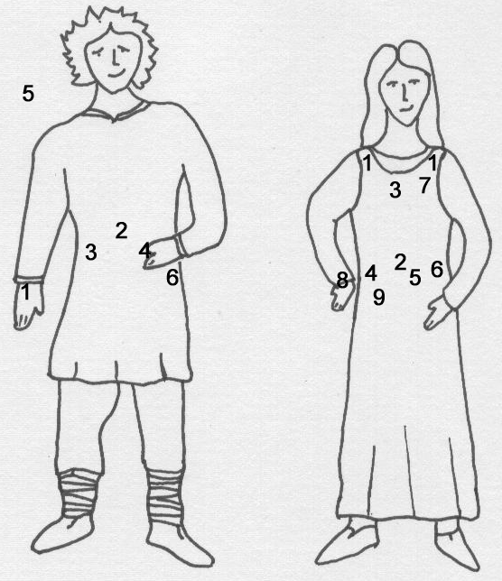
Write your answers here:
Match these objects with the numbers on the pictures
(Clue: Some objects were worn by both men and women)
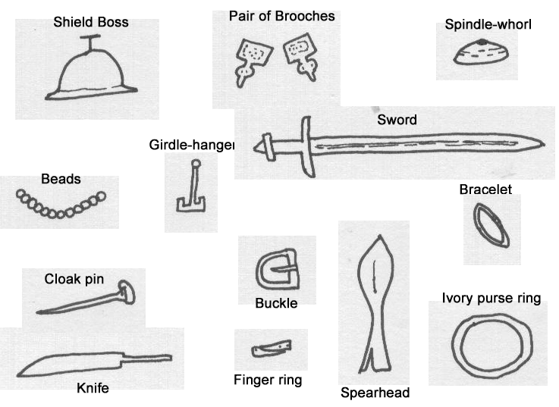

Man

Woman

